学 习 单
1、分一分。在下列图形中画一条线段，把它分成两个三角形，并说说你分出的三角形是什么三角形？

2、画一画。在点子格内，画出以下三角形：
锐角三角形、直角三角形、钝角三角形、等腰三角形。
· | · | · | · | · | · | · | · | · | · | · | · | · | · | · | · | · | · | · | · | · | · | · | · | · | · | · | · | · | ·
· | · | · | · | · | · | · | · | · | · | · | · | · | · | · | · | · | · | · | · | · | · | · | · | · | · | · | · | · | ·
· | · | · | · | · | · | · | · | · | · | · | · | · | · | · | · | · | · | · | · | · | · | · | · | · | · | · | · | · | ·
· | · | · | · | · | · | · | · | · | · | · | · | · | · | · | · | · | · | · | · | · | · | · | · | · | · | · | · | · | ·
· | · | · | · | · | · | · | · | · | · | · | · | · | · | · | · | · | · | · | · | · | · | · | · | · | · | · | · | · | ·
· | · | · | · | · | · | · | · | · | · | · | · | · | · | · | · | · | · | · | · | · | · | · | · | · | · | · | · | · | ·
· | · | · | · | · | · | · | · | · | · | · | · | · | · | · | · | · | · | · | · | · | · | · | · | · | · | · | · | · | ·
· | · | · | · | · | · | · | · | · | · | · | · | · | · | · | · | · | · | · | · | · | · | · | · | · | · | · | · | · | ·
· | · | · | · | · | · | · | · | · | · | · | · | · | · | · | · | · | · | · | · | · | · | · | · | · | · | · | · | · | ·
· | · | · | · | · | · | · | · | · | · | · | · | · | · | · | · | · | · | · | · | · | · | · | · | · | · | · | · | · | ·
· | · | · | · | · | · | · | · | · | · | · | · | · | · | · | · | · | · | · | · | · | · | · | · | · | · | · | · | · | ·
· | · | · | · | · | · | · | · | · | · | · | · | · | · | · | · | · | · | · | · | · | · | · | · | · | · | · | · | · | ·
· | · | · | · | · | · | · | · | · | · | · | · | · | · | · | · | · | · | · | · | · | · | · | · | · | · | · | · | · | ·
· | · | · | · | · | · | · | · | · | · | · | · | · | · | · | · | · | · | · | · | · | · | · | · | · | · | · | · | · | ·

3、数一数。下图中，你找到几个锐角三角形、直角三角形和钝角三角形？
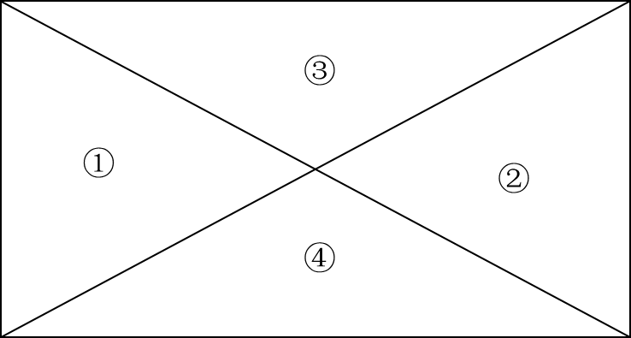
（ ）个锐角三角形
（ ）个直角三角形
（ ）个钝角三角形

