**2020**—**2021学年度第一学期期末调研试题**

**听力部分 (共30分)**

一、听句排序 **(每小题1分，共5分)**

听录音，根据所听到的顺序用阿拉伯数字给下列图片编号，并将答案填写

在图下的括号内。每个句子读两遍。

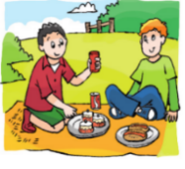

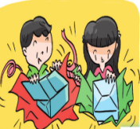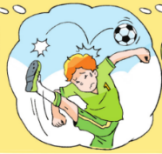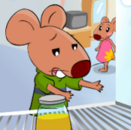

( ) ( ) ( ) ( ) ( )

二、听句应答 **(每小题1分，共5分)**

听录音，选出最佳应答语，并将答案填写在题前的括号内。每个句子读两遍。

( ) 1. A. I can see five. B. There’s only one. C. They’re two nice birds.

( ) 2. A. Long ears. B. Long tails. C. Small wings.

( ) 3. A. Let’s go and play. B. Let’s play again. C. Good idea.

( ) 4. A. Here’s a computer. B. There’s a computer. C. It’s a computer.

( ) 5. A. She’s a cook.

B. She can cook.

C. She cooks food for us.

三、听句选图 **(每小题1分，共5分)**

听录音，根据所听到的内容，选出适当的图片，并将答案填写在题前的括号内。

每段话读两遍。

( ) 1. Where is the baby bear?

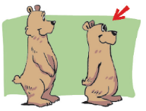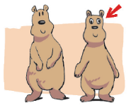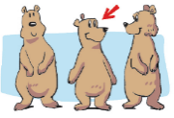 A. B. C.

( ) 2. Which is on the third floor?

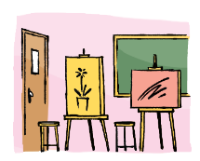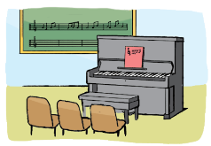 A. B. C.

( ) 3. Where does Mrs Smith live now?

A. B. C.

( ) 4. What does Mike sometimes do at weekends?

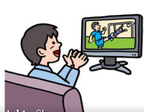 A. B. C.

( ) 5. What does Bob like doing?

 A. B. C.

四、对话理解 **(每小题1分，共5分)**

听录音，根据所听到内容，选出最佳选项，并将答案填写在题前的括号内。每

段对话读两遍。

( ) 1. Where is Billy?

A. In the playground. B. At home. C. In the park.

( ) 2. What do they talk about?

A. Jobs. B. Hobbies. C. Weekends.

( ) 3. What can Lucy do?

A. Swim. B. Skate. C. Ride a bike.

( ) 4. How is the green sofa?

A. It’s too hard. B. It’s too soft. C. It’s just right.

( ) 5. What animal does Peter like?

A. Pandas. B. Polar bears. C. Kangaroos.

五、短文理解 **(每小题1分，共5分)**

听录音，根据所听到的内容，选出最佳选项，并将答案填写在题前的括号内。

短文读两遍。

( ) 1. What animals are not in the shop?

A. Cats. B. Parrots. C. Fish.

( ) 2. What does the yellow dog have?

A. Long legs. B. A big body. C. A fat body.

( ) 3. How much is the dog?

A. Eighty-five *yuan*. B. Fifty *yuan*. C. Thirty-five *yuan*.

( ) 4. When does Peter go to the shop to get the dog?

A. In the morning. B. In the afternoon. C. In the evening.

( ) 5. Does Peter get the dog?

A. Yes, he does. B. No, he doesn’t. C. I’m not sure.

六、短文填空 **(每小题1分，共5分)**

听录音，根据所听到的内容，在相应的横线上填入一个正确的单词。短文读三遍。

At Christmas, I usually (1) ____________ Christmas cards and give (2) ____________ to my friends. I often go to see (3) ____________ Christmas. I always (4) ____________ a stocking on my bed on Christmas Eve. I have a (5) ____________ dinner on Christmas Day. After that, we sing Christmas songs. We always have a good time.

**笔试部分（共70分）**

七、单项填空 **(每小题1分，共10分)**

**从A、B、C、D四个选项中选出最佳选项，**并将答案填写在题前的括号内。

( ) 1. The girl is so ______. She shouts “help!”

A. happy B. tired C. afraid D. hungry

( ) 2. — How many ______ are there in your school?

— Two. We can read books there.

A. art rooms B. reading rooms C. playgrounds D. music rooms

( ) 3. My grandpa ______ an apple tree and______ many apples on it.

A. have; has B. has; there are

C. there is; has D. there are; have

( ) 4. — Can the boy______ Chinese?

— ______, he has Chinese lessons at school.

A. speak; Yes B. speak; No C. talk; Yes D. talk; No

( ) 5. I like fish. They have ______ arms ______ legs. But they look nice.

A. no; and B. no; or C. /; and D. not; or

( ) 6. ______ lovely rose!

A. What a B. What C. How D. How a

( ) 7. I don’t like eating cakes. But ______ I have some at the birthday parties.

A. always B. often C. sometimes D. usually

( ) 8. ______ The floor is wet!

A. Hurry up! B. Look out! C. Come out! D. Don’t worry!

( ) 9. I like reading very much, but my sister ______.

A. can’t B. doesn’t C. don’t D. isn’t

( ) 10. — Let’s watch TV together!

— ______. Let me do my homework first.

A. Don’t worry B. Sorry, I can’t. C. All right. D. Wait a minute

八、词汇检测 **(每小题1分，共12分)**

A) 用括号中所给单词的适当形式填空。每空一词。

1. Look at the parrot. It can ____________ (talk).

2. Monday is the ____________ (two) day in a week.

3. __________ (be) there any sweets on the table?

4. There are some trees between the ____________ (house).

5. My cousin usually ____________ (fly) a kite in the park.

6. Lily, they are new students. Can you show ____________ (they) around our school?

B) 根据中文提示及上下文，写出正确的单词。每空一词。

Su Hai and Su Yang are eleven. They’re (7) ____________ (双胞胎) sisters. At weekends, they usually have (8) ____________ (舞蹈) lessons. Sometimes they (9) ____________ (参观) their grandpa. Their grandpa is a (10) ____________ (农民). He has a big farm. He (11) ____________ (工作) hard every day. Grandpa has a cute cat. (12) ____________ (它的) name is Kitty. Su Yang and Su Hai like playing with it very much.

九、补全对话 **(每小题1分，共5分)**

将方框内所给句子的序号填入空格，使对话完整、通顺。

A. They have big heads and big bodies.

B. Can I have a try?

C. Let me show you around.

D. They can talk to you.

E. But I want to get some toys for my son.

A: Hello, Joe! Welcome to my toy shop!

B: Wow! There are a lot of toys in your shop.

A: (1) ______ These are some toy animals. Girls like them very much.

B: How lovely! (2) ______ Do you have any robots?

A: Yes. Look! They’re here. (3) ______

B: They look nice. What can they do?

A: (4) ______

B: Really? (5) ______ “Hello”.

A: You see, the robot says “Hello” to you.

B: Oh, it’s great.

十、看图填空 **(每小题1分；共12分)**

根据图片将对话补充完整，每空一词。

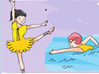1. A: Do you have any hobbies?

B: Yes. I have two hobbies. _________ is dancing

and __________ _________is swimming.

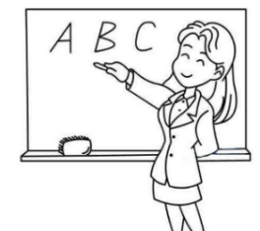2.

A: What __________your sister ____________?

B: She’s a teacher. She___________ __________.

3. A: Do you often go to see your uncle?

B: No. He lives in Beijing. I usually __________

__________ __________ on the Internet.

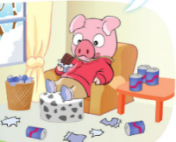

4. A: Look at Billy. He’s eating again.

B: Yes. He always eats _________ ___________.

十一、完成句子 **(每小题1分；共10分)**

1. Wang Bing is good at skating. (换一种表达，意思不变)

Wang Bing can ____________ ____________.

2. Jim likes playing the piano. Tom likes playing the piano too.

(两句合并成一句，意思不变)

Jim and Tom ____________ ____________ playing the piano.

3. Is there a clock in your classroom? (根据实际情况回答问题)

_________________________________________________

4. What do you usually do at weekends? (根据实际情况回答问题)

__________________________________________________

5. What does a doctor do? (根据实际情况回答问题)

__________________________________________________

十二、完形填空 **(每小题1分，共6分)**

阅读短文，根据上下文选择最佳选项，并将答案填写在题前括号内。

Jack has no friends but he has a big garden. There are many beautiful flowers and some fruit trees in it. It’s autumn. Many children go to the 1 . They play games and listen to the birds singing there. They are very 2 .

One day, Jack comes back home. He 3 children playing in his garden. “Go out!” he shouts. The children go away.

4 comes, but in Jack’s garden it is still (仍然) winter. There are 5 children. The birds don’t like to 6 . The flowers don’t want to grow.

“How foolish (愚蠢的) I am!”, says Jack. Then he asks the children to come to his garden. The garden is beautiful again.

( ) 1. A. school B. classroom C. garden D. park

( ) 2. A. tired B. happy C. sad D. thirsty

( ) 3. A. wants B. doesn’t want C. likes D. doesn’t like

( ) 4. A. Spring B. Summer C. Autumn D. Winter

( ) 5. A. no B. some C. a lot of D. any

( ) 6. A. fly B. jump C. sing D. run

十三、阅读理解 **(每小题1分，共10分)**

A）阅读短文，判断句子与短文内容是否相符，相符的在题前括号内写T，不相符的写F。

Linda is five years old. It is her first day at school. She goes to school in her mother’s car. The other children in her class are very nice. Her teachers are very nice to them too. She likes them very much. The students have an Art lesson, a Music lesson, a PE lesson, a Maths lesson and an English lesson. At two o’clock, she goes back home with her mother.

The next day, when she sees the teacher, she asks the teacher a question (问题). “What do I do at school today, Miss Li?”

“Why (为什么) do you ask me this question?” Miss Li asks her. “My mother asks me the question at home.” She answers.

( ) 1. Linda goes to school by car.

( ) 2. Linda has six lessons on the first day.

( ) 3. Linda likes going to school very much.

( ) 4. Linda comes back home late in the afternoon.

( ) 5. Linda can answer her mother’s question.

B）根据短文内容，选择最佳选项，并将答案填写在题前的括号内。

This Sunday, Betty plays with Richard and Helen. They play volleyball and climb trees in the park. “This is boring. Let’s play a fun game.” says Helen. They go to her house. Helen opens a big red umbrella and stands on a chair. Then she jumps off. “Look! I can fly!” she says. “That chair isn’t very high,” said Richard. “Watch me!” He takes the umbrella and jumps off a table.

Betty wants to fly, too. She wants to jump off the balcony (阳台). “No! It’s too high!” shouts Richard. “It isn’t very high,” says Betty. Betty can see the soft grass on the ground. She is very afraid, but she opens the umbrella and jumps. She falls into (跌入) some flowers.

Betty hurt her legs. She goes to see the doctor. The doctor says “Your legs are OK, Betty. But don’t try to fly again!” The next day, the children in her class give her a funny card. Inside it says, “Go by plane next time, Betty!”

( ) 6. ______ children play with Betty this Sunday.

A. Two B. Three C. Four. D. Five.

( ) 7. The word “boring” means ______ in Chinese.

A. 有趣的 B. 无聊的 C. 刺激的 D. 累人的

( ) 8. Helen can’t ______.

A. play volleyball B. climb trees

C. fly D. play fun games

( ) 9. Richard jumps off ______ to fly.

A. a tree B. a chair C. a table D. the balcony

( ) 10. Betty is afraid because (因为) ______.

A. she sees the grass B. she falls into some flowers

C. the balcony is too high D. she has no umbrella

十四、书面表达 **(5分)**

根据下面的问题，以短文形式介绍一下你的一位好朋友。

1. Who’s your good friend?

2. How old is he/she?

3. Do he/she have an animal friend?

4. What subject does he/she like?

5. What does he/ she like doing after school?

要求：1. 所写内容需包含以上所有信息，可适当补充内容；

2. 条理清晰，语句通顺, 标点正确，书写规范；

3. 不少于5句话。

____________________________________________________________________

_________________________________________________________________________________________________________________________________________________________________________________________________________________________________________________________________________________________________________________________________________________________________________________________________________________________________