星河实验小学教育集团六年级英语上册调研试卷（2020.12）
学校 班级 姓名
…………………………………………………………………装……………订……………线……………………………………………………………………………………

得分：
第一卷 听力部分（共 20分）
一、听力 (共 20 分)
A) 听录音，选出你所听到的单词、短语或句子。(读两遍,共 6 分)
( )1. A sign B nine C fine
( )2. A project B protect C poster
( )3. A about B beside C around
( )4. A bad eggs B dead fish C waste bottles
( )5. A light firecrackers B get red packets C watch lion dance
( )6. A John is going to help pick apples on the farm next Saturday.
B John isn’t good at writing. He likes reading.
C John is too thirsty and he’d like a glass of water.
B) 听录音，听录音，根据录音内容选择正确的答案。(读两遍，共 5 分)
( )1. A Keep away. B Smoking. C Wet floor.
( )2. A Sorry, Mr. Green. B What about you? C OK! I do.
( )3. A Not so sweet. B Good idea. C What’s wrong?
( )4. A Very pretty. B Too high. C Not so good.
( )5. A No, it isn’t. B Yes, it is. C Sure not.
C) 听录音，根据录音内容选出能回答问题的最佳答案。 (读两遍，共 5 分)
( )1. A To visit his friend. B To visit the park. C To visit his aunt.
( )2. A Christmas Day. B May Day. C Children’s Day.
( )3. A In the zoo. B In the park. C In his home.
( )4. A Oil. B Coal. C Water.
( )5. A Sunny. B Cloudy. C Rainy.
D) 听短文，在句中空白处填入你所听到的单词。(读二遍，共 4 分)
Peter and his friends had a trip in the forest near their school. It was very ___________. Peter was
both ___________ and thirsty. He took out a bottle of juice to ___________. Then he was eating some
bananas and threw the banana’s skin on the __________. Later, Peter slipped on the skin and fell over.

第二卷 笔试部分（共 80 分）
一、语音。（8分）
A）选出下列各组词中划线处读音与题前例词相同的项。（共4分）
1. ( ) cook A foot B food C school
2. ( ) listened A pushed B visited C climbed
3. ( ) use A under B cute C ruler
4. ( ) skirt A forty B turn C party
B）选择划线部分发音相同的单词完成下列句子。（共4分，每格1分）
1. The small ________ is playing with a green toy _________, not a toy horse. ( third, girl, bird, word)
2. Tina’s room is too dirty. __________! The _________are all over the floor. (books, cook, cool, look)

二、词汇与句型。
A)单项选择。（10分）
( )1. --- Where’s Helen? --- She’s _________ the hot dog in her bag behind the tree.
A looking after B looking around C looking for
( )2. --- I have some bananas here. Do you want ________, Jim? --- All right, thank you.
A one B it C many
( )3. Look at the sign ‘_______’. We can’t swim in this river.
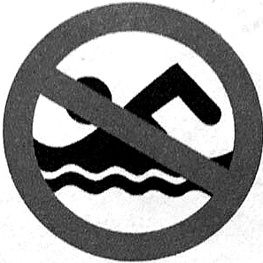
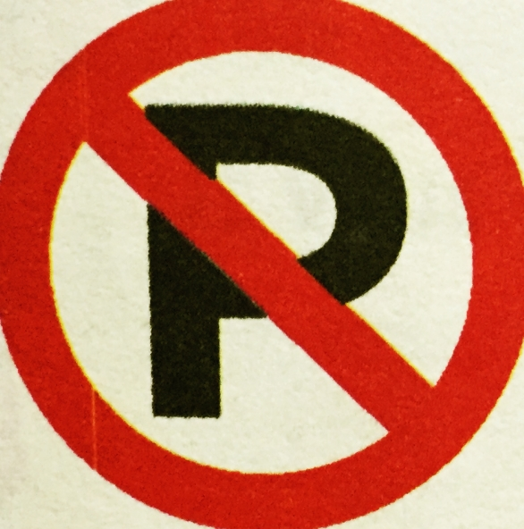
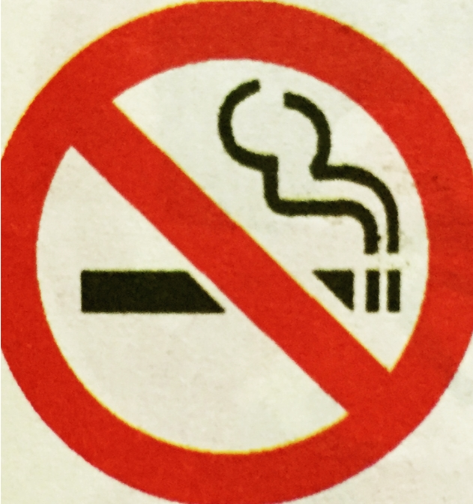
A B C
( )4. --- What can we do ________ energy? --- We can walk or take the bus to school.
A to save B save C saving
( )5. --- There are _______ people using water every day on the Earth. --- So we can’t waste ______ water.
A many too, so many B so many, too much C so much, much too
( )6. --- What ________ you _________ do tomorrow? --- To have a party for our friend Mary.
A do, to do B did, 不填 C are, going to
( )7. --- Which festival is the most important in _________? --- _________.
A China, Spring Festival B Changzhou, Christmas C the UK, Mid-Autumn Day
( )8. --- _________ you in the library just now? --- No, we _________ fishing with Helen.
A Did, wanted B Were, went C Did, go
( )9. --- What _________ we do in the library? --- We _________ eat or drink anything.
A can’t, can B shouldn’t, shouldn’t C should, should
( )10. --- What did you _________ last Friday evening? --- I_________ to music with my cousin.
A do, listen B did, listened C do, listened
B）用所给中英文或图片的正确形式填空（每格一词，满分10分）
1. As we all know smoke from factories ______________(make) the air very dirty.
2. Look! How ______________ (mess) Jack’s bedroom looks!
3. Plastic is very _______________(use), but we can’t use too much.
4. --- I can’t find my honey. I _______________(bring) it with me this morning. --- Really?
5. Look at the ______________(shop) center building (大楼). --- How modern it is!

6. --- What does the sign mean? --- It means ______________.
7. Everything ____________ ____________ (就绪). Let’s start our show. --- All right.
8. I want to know if you are _____________ _____________ (对---兴奋) the coming Children’s Day?
C）选择方框中合适词组的句子的序号，填在句子前面的括号内。（满分6分）
A. walk on B. next week C. away from D. go in E. takes---to F. well done
( ) 1. They moved the paper factory ________ the town center five years ago.
( ) 2. --- Lucy looks really too tired and she can’t _______. --- OK! Let’s stop to have a rest (休息).
( ) 3. Usually Mr. Fox ________ the metro ________ work every day.
( ) 4. --- What are you going to do _________? --- To visit my grandfather on a farm
( ) 5. --- We had a wonderful fashion show yesterday, Mrs. Su. --- ________.
( ) 6. --- I’m hungry, Mum. --- OK! There is a restaurant here. Let’s ________.

三、交际。（共15分）
A）从第Ⅱ栏中选出第Ⅰ栏的正确答句，把序号填在前面括号内。（共8分）
( ) 1. Jim didn’t come to our party. Why? A. Thank you.
( ) 2. Does the sign mean ‘Wet floor’? B. On 5 June every year.
( ) 3. How is the air in your city? C. He is ill in hospital.
( ) 4. What city do you like living in? D. Yes, it does.
( ) 5. We should reuse and save waste things? E. Not so nice.
( ) 6. When is World Environment? F. To visit Yan Cheng Park.
( ) 7. What are you going to do tomorrow? G. A clean and beautiful one.
( ) 8. This is a new toy car. Here you are. H. That’s a good idea.
B）根据图文信息，在句子的横线上填入一个适当的词完成对话 (共7分)。
A: Look at the sign. What does it mean?
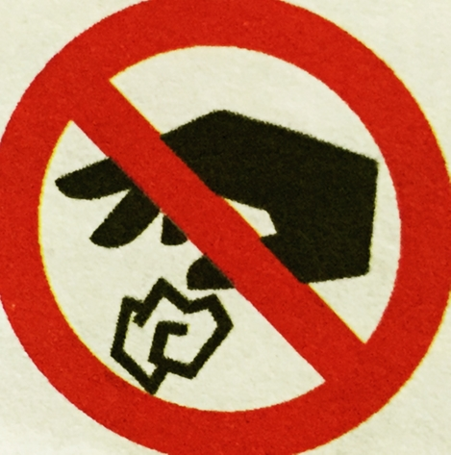
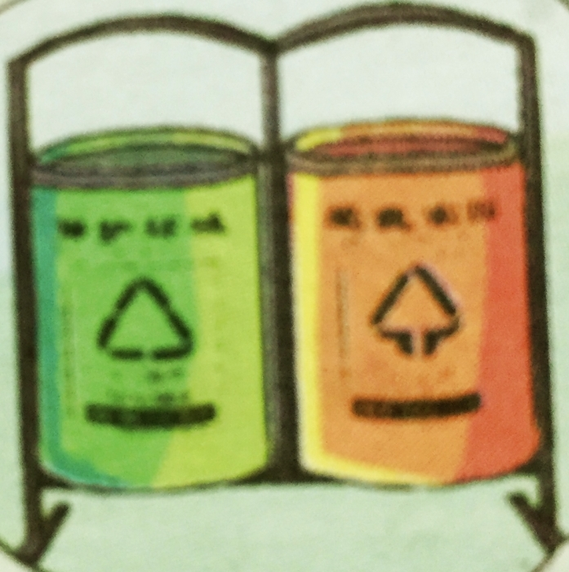
B: It ____________ ‘No littering’.
A: Oh. Then where can we ____________ waste things?
B: We can put in the _____________.
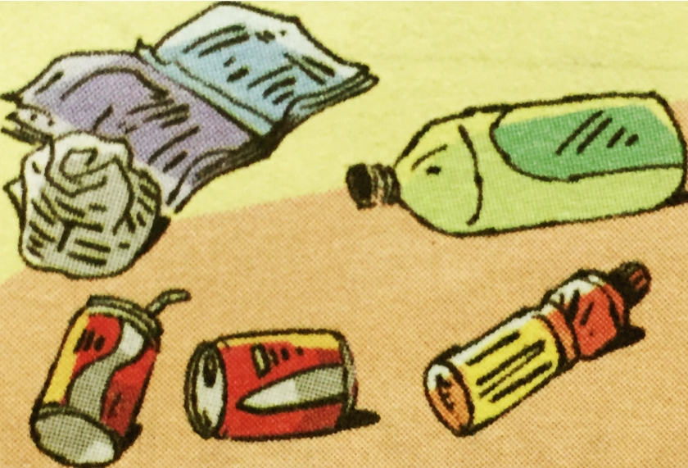
A: Look! There is so much _____________ on the ground.
B: It looks so dirty. What are they?
A: They are waste _____________ and plastic bottles.
B: That’s too bad. We can’t litter things ______________.
A: Yes. We can use waste plastic to ______________ toys or bags.
四、阅读。（共21分）
A）首字母填空。阅读短文，根据首字母提示填写单词（共6分）
Liu Tao is twelve years old and tomorrow is his b__________. His father b__________ him a nice toy robot and his mother is going to make a big cake and have a party at home f_________ him. His uncle and aunt are coming too. They are going to send h_________ some nice presents. Liu Tao asked his friends to come to his party, t________. They will play games, sing and dance at the party. Liu Tao is very h________ and Liu Tao can have a wonderful birthday.
B）阅读短文，选择正确答案。（共5分）
Once there was a farmer. He worked for a landlord (地主). The landlord made the man work all day, but paid (给钱) him very little money (少钱) and didn’t give him enough (足够的) food to eat.
One day when the man was having breakfast, the landlord came and said to him. “It’s too trouble (麻烦) to go to work and come back for supper. So I want you to have breakfast and lunch and supper now, before you go to the field (田地).”
“How can I eat three meals (餐) at the same time?” The man thought. But he said, “All right” He finishes his breakfast and went out.
Two hours later (后), the landlord went out for a walk. Now what did he see? He saw the man sitting under a tree and smoking. The landlord was very angry.
“Why aren’t you working in the fields?” He said. The man said with a smile, “I have had (已吃过) my supper and you know very well what I should do after supper.”
( ) 1. The landlord gave the farmer ________.
A very little sleep B very little work C much food to eat D very little money
( ) 2. The farmer had three meals together because ________.
A it was good for the landlord B it was good for the farmer
C the landlord was very kind D the farmer liked to do that
( ) 3. Two hours later, the landlord saw the farmer _________.
A working hard on the farm B having his lunch under a tree
C sleeping under a tree D smoking under a tree
( ) 4. The farmer told the landlord that after supper it was time _________.
A to work B to rest C to watch TV D to sit under a tree
( ) 5. From the story, we can know that the farmer was very _________.
A tired B angry C clever D foolish
C）阅读短文，完成下列信息表。（共5分）
What a fine day it is today! It is nine o’clock in the morning. There is a sports meeting (运动会) in the forest. A lot of little dog’s friends are there. Look, there is a rabbit, a cat, a dog, a goat (山羊) and a
panda. They are running. Near the river, there are two tigers. They are jumping. In the tree, there are five
monkeys. They are climbing. Eight birds are flying and singing.
There’re some other animals there, too. A monkey is sitting on an elephant. He has a flag (旗帜) in his hand. Oh, many birds are sitting in the tree. They are watching the game. How happy they are!
A Sports Meeting
The little dog and his friends are having a sports | ◆ meeting in a forest on a ___________ day.
◆ The rabbit is _____________ with the cat, | the dog and the goat at the meeting.
◆ The two ______________ are jumping near | the river.
The birds aren’t good at jumping but they can | ◆ fly high and _____________ well.
◆ Monkeys are funny and one of them is _________ | on an elephant’s back with a flag.
五、书面表达。（共10分）
根据下面的问题请以短文的形式记录你某一天的活动。如周末，节日等。
要求：
1. 补全标题 2. 语句通顺，表达正确 3. 不低于8句 4. 完成标题。
1. When and where did you go? (went to) 2. Who went with you? (我父母)
3. How was the weather? (暖和，晴朗) 4. What did you do / see? (美丽的花, 放风筝，去划船)
5. How did you feel (感觉)?（有点儿累，但很快乐，度过了美好的周末）
My _________________
Last weekend, I went to the Yan Cheng Park. I went there____________________. It ___________
_______________. We walked in the park. The park is very beautiful. There are ___________________
___________________________________ in it. We _________________________________________
______________________. We were _____________________________________________________.
We had a wonderful weekend.

星河实验小学教育集团 六 年级英语上册调研试卷
听力稿
一、听录音，选出你所听到的单词、词组或句子。（读两遍）
1. Jim, here’s a sign. What does it mean?
2. Everyone should do something to protect our Earth.
3. The lake is so beautiful and there are some hills around it.
4. The water in the river is too dirty and you can see many dead fish in it.
5. On Chinese New Year’s Day, people can watch lion dance.
6. John is going to help pick apples on the farm next Saturday.
二、听录音，根据录音内容选择正确的答案。（读两遍）
1. Here’s a sign at the shop gate. What does it mean?
2. Don’t laugh at the old people, Mike. 3. We can take the metro to school to save energy.
4. How is the air in some big cities now? 5. Is Thanksgiving Day very important in the US?
三、听录音，根据录音内容选出能回答问题的最佳答案。（读两遍）
1. W: I’m going to visit my uncle in Long Cheng this weekend, John.
M: Good idea! I’m going to the hospital to visit my aunt. Q: What’s John going to do this weekend?
2. W: My favourite festival is Christmas Day, Mike.
M: Great, Lucy. My favourite festival is May Day, Lucy. Q: What’s Lucy’s favourite festival?
3. W: Were you at home yesterday, Liu Tao?
M: No, we went out to help clean the park Q: Where was Liu Tao yesterday?
4. W: Water is very useful, Tim. M: Yes, we use it to clean things every day.
Q: What are they talking about?
5. W: Was it cloudy yesterday? M: No, it was sunny in the morning but rainy in the afternoon.
Q: How was the weather yesterday morning?
四、听录音，在句子的空白处填入你所听到的单词完成短文。（读两遍）
Peter and his friends had a trip in the forest near their school. It was very hot. Peter was both hungry
and thirsty. He took out a bottle of juice to drink. Then he was eating some bananas and threw the
banana’s skin on the ground. Later, Peter slipped on the skin and fell over.

