新版译林四年级（上）期末试卷
姓名____________ 得分____________
听力部分（30分）
一、听录音，选出你所听到的内容。（听两遍） (10分)
（ ）1、A. any B. many C. twenty
（ ）2、A. dogs B. dolls C. balls
（ ）3、A. eyes B. ears C. nice
（ ）4、A. thirty B. thirsty C. thirteen
（ ）5、A. in the kitchen B. in the bedroom C. in the living room
（ ）6、A. a cup of coffee B. a glass of juice C. a glass of milk
（ ）7、A. seven B. eleven C. fifteen
（ ）8、A. big and red B. red and small C. fat and short
（ ）9、A. What would you like?
B. Would you like an orange?
C. What do you have?
（ ）10、A. 40 fat dogs B. 14 fat dogs C. 40 cats and dogs
二、听录音，给下面的图片标序号。（听两遍）(8分)

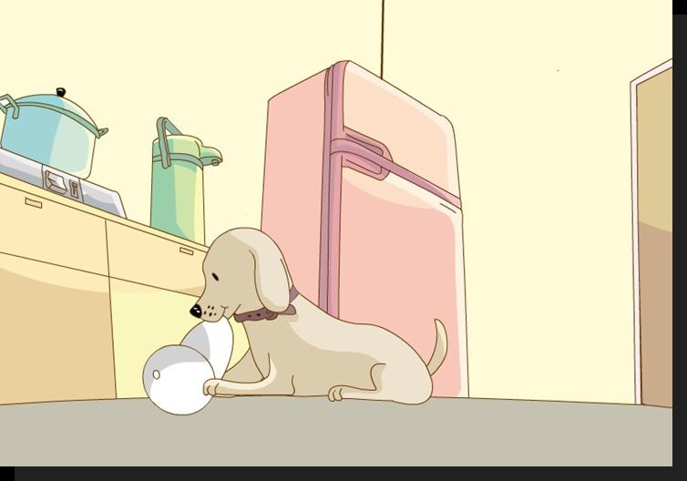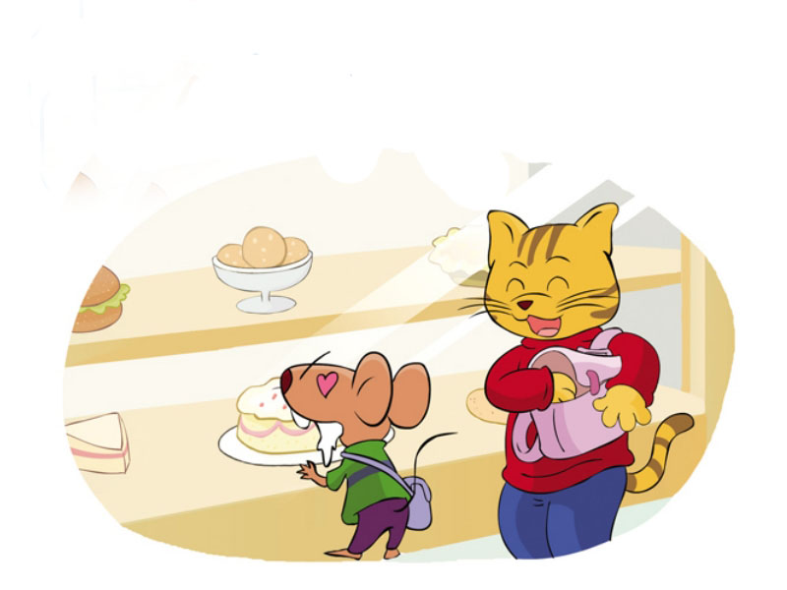
( ) ( ) ( ) ( )
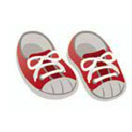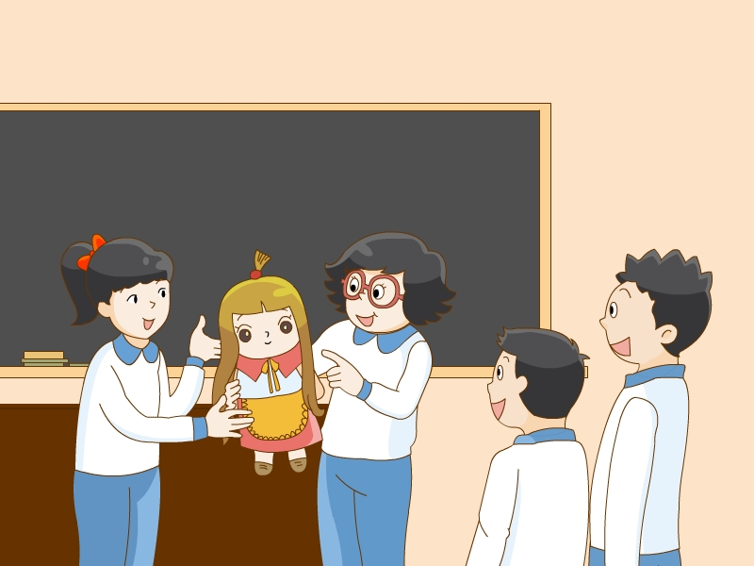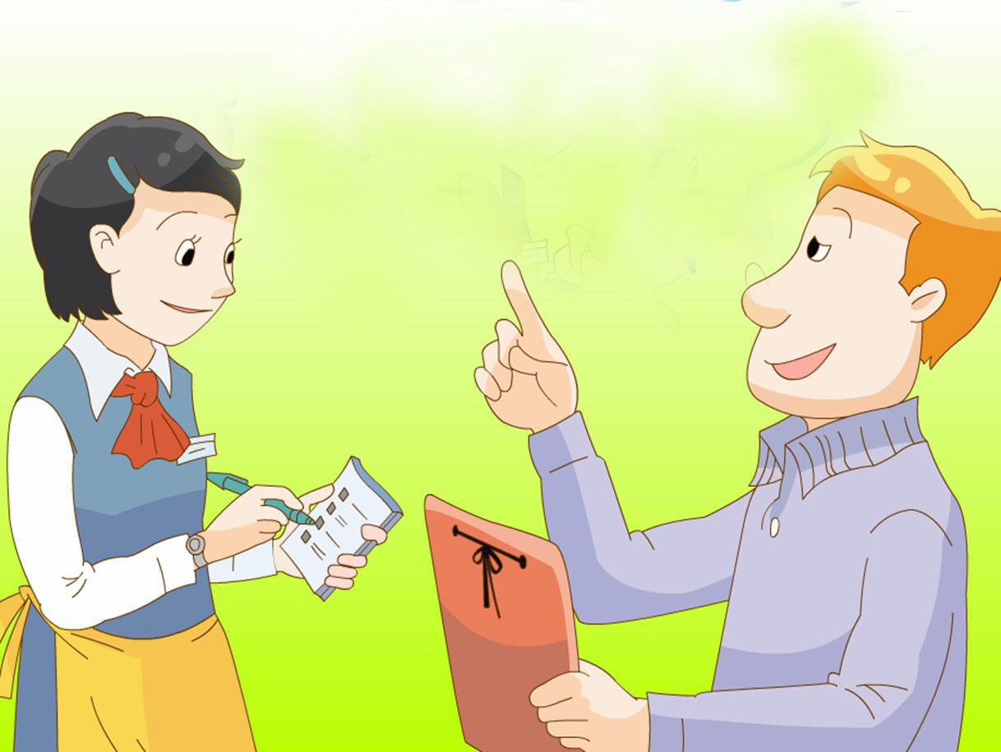
（ ） ( ) ( ) ( )
三、听录音，根据所听内容选择正确的应答。（听两遍）(5分)
( )1.A. I have three bananas. B. I can see three. C.I like bananas .
( )2. A. Yes ,I can . B.I can see three. C.I can skate.
( )3.A. No, I can’t. B. No, I don’t . C. Yes , please.
( )4. A. They’re nice. B. Yes, I do. C. It’s very cute.
( )5.A.I like dogs . B. Some fruit salad. C. Yes, please.
四、听录音, 填入所缺的单词.(7分)
Hello! My name is Tom.I can _______, I can’t _______.This is Lucy, She’s my sister. She’s nine. She can play _______ _______. She can’t _______. That’s my brother, peter. He’s four. He can’t play football. He can _______ and _______.
笔试部分（70分）
一、补全单词并写出其中文意思。（10分）
1. p da 2. a ad
3. f f een 4. o derf l
5. t g r 6. re
7. th ty 8. f i ge
9. g p 10. k chen
二、英汉互译。(10分)
1. 这些玩具熊猫__________________ 2. a glass of juice_________________
3. 多少钱_______ __ _____ 4. eat some cakes_______________
5. 她的小鼻子 _________________ 6. love to skate___________________
7、喜欢大象________________ 8.anything else ___________________
9、一杯茶 10.Don’t be sad.
三、选择填空。(15分)
( )1.Can you ?
A. swimming B. swim C. swims
( )2.---What you like ?
---_____like a sandwich.
A. do ,I B. would, I’d C. would , I
( )3. —Do you like ________?
—No, I don’t.
- cat B. monkey C. it
( )4. —Look at our fruit salad.
—________
A. Yes, I do. B. How nice! C. Thank you.
( )5. —Can you play table tennis?
—No, I ________.
A. am not B. do not C. can’t
( )6. —How many ________ do you have?
—________.
A. mango; Two B. mangoes; Two C. mangoes; Too
( )7. —Where ________ my shoes?
—They’re in the ________, under the bed.
- are; bedroom B. is; bedroom C. are; living room
( )8.---Can you see the boy the tree?
----Yes ,I can.
- with B.in C.on
( )9.I don’t have a doll, .
A.too B.either C.then
( )10.He can jump .
A.well B.good C.nice
( )11.—Do you like_____?
--- Yes ,I ．
A. apples, do. B. apples，like C. an apple ,do
( )12.----Can you play _______? ----Yes,I can.
A.basketball B.a football C.the basketball
( )13.--- you like some grapes? ------No ,thank you .
- Do B. Would C. Are
( )14.-- toy cars do you have? ---Ten.
- What about B. How many C. How much
( )15.I have some pens. in the pencil box.
A. It’s B. They’re C. I’m
四、连词成句。（5分）
- you ,like , What, would(?)

- at ,cakes ，those, look.(.)

- jump, you, can(?)

- you, any, Do, have, pies(?)

- footballs, how ,have ,many ,do you.(?)

- 在II栏中找出与I栏中相应的答句。（5分）
I II
( )1. Look at this elephant. I like elephants A. Yes, I can.
( )2. Would you like some fruit salad? B. It’s cute.
( )3. Do you like grapes? C. Yes, I’d like these apples.
( )4. Dad, where’s my cap? D. No, I don’t.
( )5. Can you see the box? E. It’s in your bedroom.

六、排序。（4分）
1. Thanks, Dad. Now, I’m hungry.
2. No, they aren’t.
3.OK,it’s in the fridge.
4.What about an egg?
5. Are they on the sofa?
6. No, I’d like a cake..
7.Dad,where are my socks?
8. Look ,they are in the box.
七、阅读理解。(16分每空一分) （A）
This is Mary’s room. It’s big and nice. We can see some kites on the front wall (前墙). On the back wall(后墙), there’s a clock. Look, it is four fifty now!
We can see a desk and bed in her room. The desk is near the window. Where are her bag and pencil-box? They’re on the desk. What’s on the bed? We can see a pair of socks. Mary likes them, but they’re too short.
Mary and her friend Kate like this room very much! They like to play here!
(一).判断对错,正确的用“T 表示,不正确的用“F”表示.
1. ( ) We can see a clock on the back wall.
2. ( ) It’s five forty now.
3. ( ) We can see a desk and bed in her room.
4. ( ) The jeans are too short.
(二). 根据短文内容填空。
1. Mary’s room is _________ and ____________.
2. We can see some ____________ on the front wall.
3. Mary’s pencil-box is __________ the ____________.
4. We can see a ________ of socks on the bed.
5. Mary and Kate _______ this room very much.
(B)
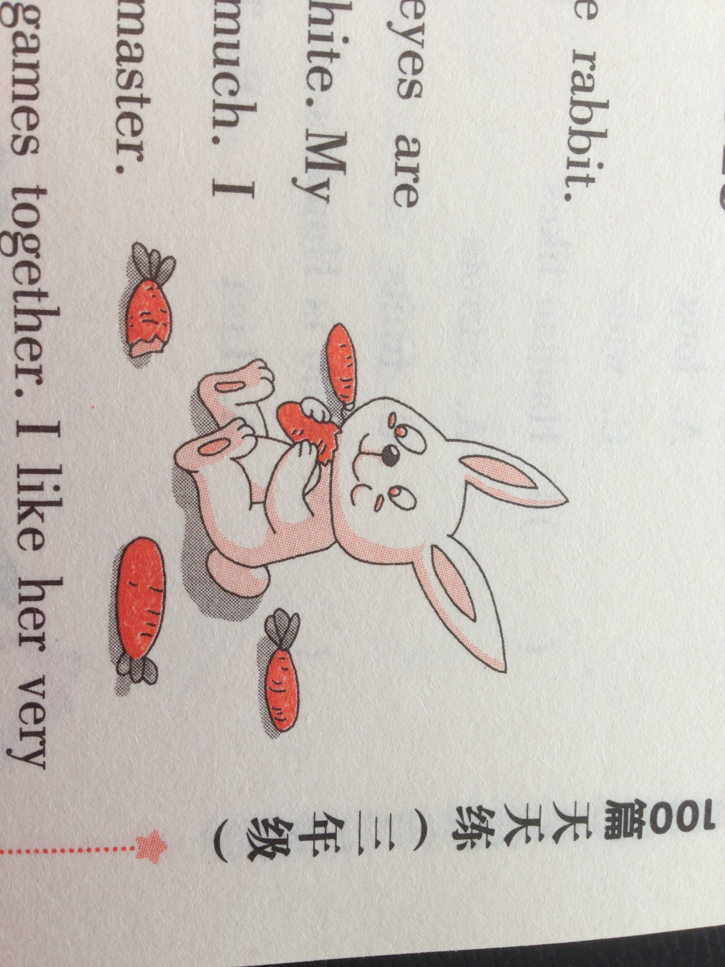
Hello, everyone! I’m a little rabbit. My name is Hanhan.
Look! I’m very lovely. My eyes are red. My ears are long. My hair is white. My tail is short. I like carrots very much. I have a good friend. She’s my little master. Her name is Lisa. We always play games together. I like her very much and she likes me, too.


rabbit /'ræbɪt/ n. 兔子carrot /'kærǝt/ n. 胡萝卜
master /'mɑ:stǝ/ n. 主人game /geɪm/ n. 游戏
together / tǝ'geðǝ/ adv. 一起 always 总是
新词速记

根据短文内容选择正确答案。
( )1. What is the rabbit’s name? The rabbit’s name is ________.
- Hanhan B. Huahua C. Tom D. Tommy
( )2. —What colour are Hanhan’s eyes?
—Hanhan’s eyes are ________.
- black B. red C. yellow D. blue
( )3. Hanhan’s tail is ________.
- long B. tall C. big D. short
( )4. Hanhan likes ________ very much.
- carrots B. eggs C. fruits D. hamburgers
( )5. —Who is Hanhan’s master?
—Hanhan’s master is ________.
- Hanhan B. Tom C. Lisa D. Jim

八、仿照例子写句子。（共5分）
例: She is a girl. He ____________.
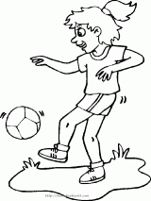
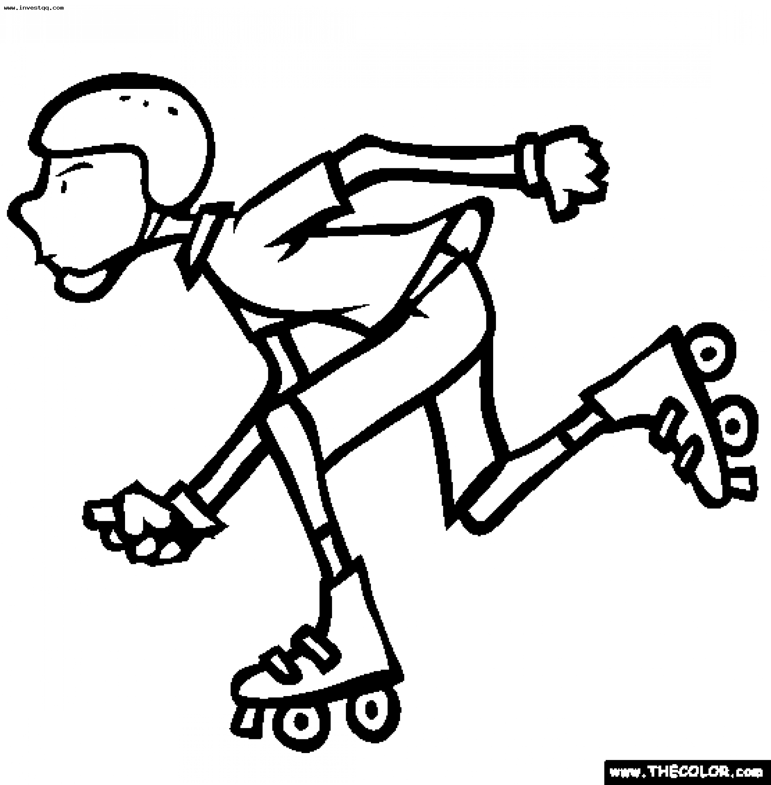
Her eyes are big. ________________
Her hair is long. ________________
She can play football ________________
very well. ________________

四年级上学期英语期末调研试卷
听力原稿和答案
一、听录音，选出你所听到的内容。（听两遍） (10分)(BCABA CAAAB)
1、many 2、balls 3、eyes 4、thirsty
5、in the kitchen 6、a glass of milk 7、seven 8、big and red
9、What would you like? 10、14 fat dogs
二、听录音，给下面的图片标序号。（听两遍）(8分)(2453 7861)
1. —Can I help you? —I’d like a hamburger and a cup of coffee .
2. —Where’s my cap? —It’s in the kitchen.
3. —I have two apples, what do you have? —Some grapes.
4. —What would you like, Bobby? —I’d like a cake.
5. —Can you jump? —No, I can swim.
6. —This is my doll.—It’s nice.
7. —How many stickers do you have?—Thirty.
8. —Look at my new shoes.—They are nice.
三、听录音，根据所听内容选择正确的应答。（听两遍）(5分)(ACABB)
1 How many bananas do you have?
2. What can you do?
3. Can you skate?
4. Do you like pandas?
5. What would you like?
四、听录音, 填入所缺的单词.（7分）
Hello! My name is Tom .I can _swim______, I can’t _skate______. This is Lucy, She’s my sister. She’s nine. She can play __table_ _ _tennis_____. She can’t __jump___. That’s my brother, Peter. He’s four. He can’t play football. He can __sing_ and__dance__.

笔试部分答案：
一．1.panda 2.salad 3.fifteen 4.wonderful 5.tiger
6.sure 7.thirsty 8.fridge 9.grape 10.kitchen
二．1.these toy pandas 2. 一杯果汁 3.how much 4.吃一些蛋糕 5.her small nose
6.喜欢溜冰 7.like elephants 8.还要别的什么吗 9.a glass of tea 10.别难过
三．BBCBC BABBA AABBB
四．1.What would you like?
2.Look at those cakes .
3.Can you jump?
4.Do you have any pies?
5.How many footballs do you have?
五．BCDEA
六．7528 1463
七．(A)（一）TFTF
（二）1.big nice 2.kites 3.on desk 4.pair 5.like
(B) ABDAC
八．He is a boy.
His eyes are small.
His hair is short.
He can skate very well.

